HW1: Mid-term assignment report

*Alexandre Pedro Ribeiro [108122]*, v2024-04-05

1 Introduction 1

1.1 Overview of the work 1

1.2 Current limitations 1

2 Product specification 2

2.1 Functional scope and supported interactions 2

2.2 System architecture 2

2.3 API for developers 2

3 Quality assurance 2

3.1 Overall strategy for testing 2

3.2 Unit and integration testing 2

3.3 Functional testing 3

3.4 Code quality analysis 3

3.5 Continuous integration pipeline [optional] 3

4 References & resources 3

<All remarks like this should be removed from the final document!

This a template for the expected **content/structure**. You may use any editing tool to prepare the report (LaTeX included).

Feel free to write in Portuguese or English, but do not mix languages between headings and body…>

# Introduction

## Overview of the work

This report presents the midterm individual project required for TQS, covering both the software product features and the adopted quality assurance strategy.

<briefly introduce your application: name the product, if applicable; what is its purpose?>

## Current limitations

 <explain the known limitations 🡪 unimplemented or faulty (but expected) features>

# Product specification

## Functional scope and supported interactions

<functional description of the application: who (actors) will use the application and for what? Briefly explain the main **usage scenario.** >

## System architecture

<briefly present the software architecture. Include one or more diagrams.>

<detail the specific technologies/frameworks that were used>

## API for developers

<what services/resources can a developer obtain from your project? document your API endpoints>

<note: for the homework, you are expected to expose two “groups” of endpoints:

* Problem domain: get the environmental data data by region/city, etc.
* Cache usage statistics: how many hits/misses,… >.

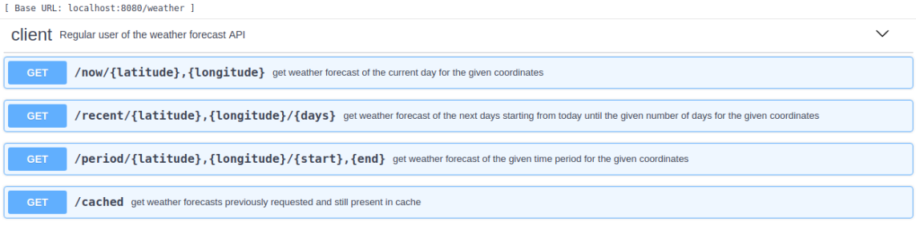

# Quality assurance

## Overall strategy for testing

[what was the overall test development strategy? E.g.: did you do TDD? Did you choose to use Cucumber and BDD? Did you mix different testing tools, like REST-Assured and Cucumber?...]

I chose to start my work by using Cucumber and BDD to describe the user stories I wanted to develop.

## Unit and integration testing

[where did you use unit and integration test? for what? which was the implementation strategy?]

[may add some screenshots/code snippets for clarification]

## Functional testing

[which user-facing test cases did you considered? How were they implemented?]

[may add some screenshots/code snippets]

## Code quality analysis

[which tools/workflow did you use to for static code analysis? Show and interpret the results.]

[you may add some interesting lessons learned, e.g., some code smell reported by the tool that was difficult to spot and otherwise you wouldn’t address it]

In my initial setup of the homework project, I setup SonarCloud in order to have static code analysis right from the start. Everytime I push to the repository, there is a GitHub Action that runs and evaluates the new code, checking if it passes the quality gate.

…

## Continuous integration pipeline [optional]

[did you implement a CI pipeline? What was the setup? Illustrate with screenshots, if applicable]

My CI pipeline consists of a set of GitHub Actions that run everytime I push new code.

Initially, I had Sonarcloud for static code analysis, Java CI for Maven and CodeQL for security.

# References & resources

Project resources

|  |  |
| --- | --- |
| **Resource:** | **URL/location:** |
| Git repository | <link to your TQs repo> |
| Video demo | < short video demonstration of your solution; consider including in the Git repository> |
| QA dashboard (online) | https://sonarcloud.io/summary/new_code?id=Sytuz_TQS_108122 |
| CI/CD pipeline | [**optional**; if you have th CI pipeline definition in a server, place the URL here] |
| Deployment ready to use | [**optional**; if you have the solution deployed and running in a server, place the URL here] |

Reference materials

<document the key components (e.g.: libraries, API) or key references (e.g.: blog post) that were helpful and certainly **would help other students pursuing a similar work**>

<https://github.blog/2022-02-02-build-ci-cd-pipeline-github-actions-four-steps/>